**Creating a GIT Repository and Folders:**

**1.** **Login to GitHub:**

- Open your web browser and go to github.com.

- Sign in to your GitHub account.

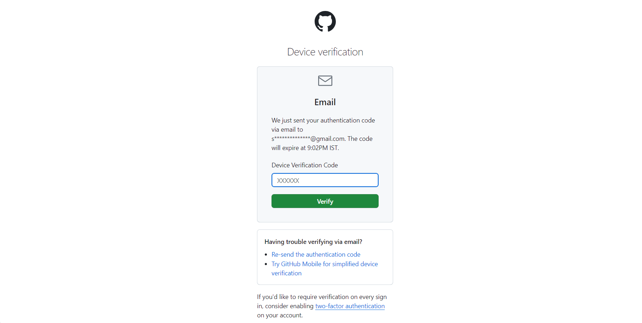

**2.** **Create a New Repository**:

- Click on the "+" icon in the top-right corner of the GitHub dashboard.

- Select "New repository" from the dropdown menu.

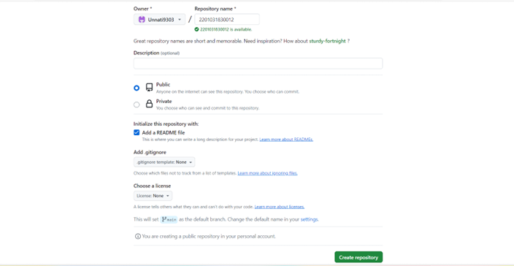

**3.** **Name Your Repository:**

- Choose a name for your repository. It should be your enrollment number.

- Optionally, add a description for your repository.

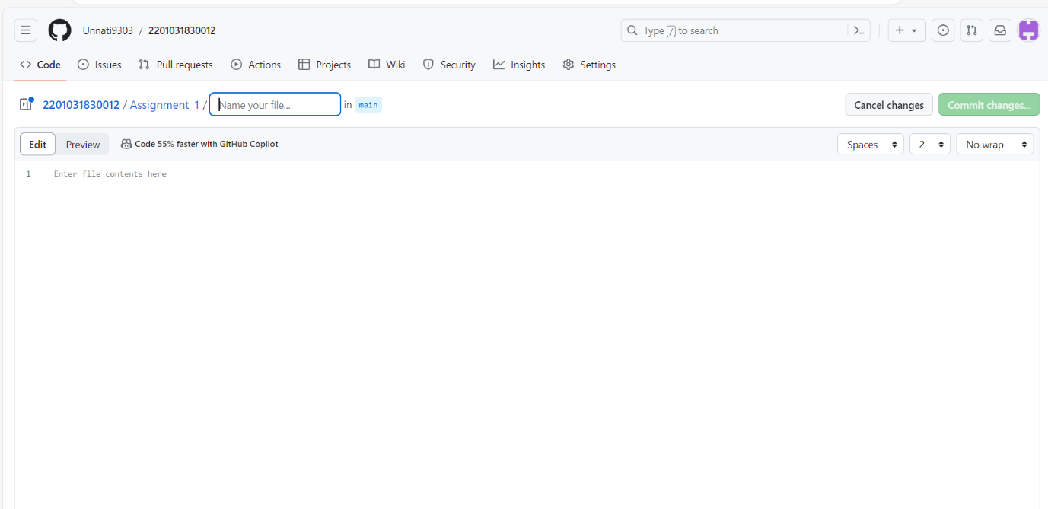

**4. Initialize the Repository:**

- Choose whether to initialize the repository with a README file. For this task, leave it unchecked.

- Click on the "Create repository" button.

5. **Clone the Repository:**

- Once the repository is created, click the green "Code" button.

- Copy the URL provided.

**6.** **Open Command Line Interface (CLI):**

- Open your preferred CLI (Command Prompt, Terminal, Git Bash, etc.).

**7.** **Navigate to Desired Directory:**

- Use the `cd` command to navigate to the directory where you want to store your local repository copy.

**8. Clone the Repository:**

- In the CLI, type `git clone <repository_URL>` and press Enter.

- Replace `<repository_URL>` with the URL you copied from GitHub.

- This will create a local copy of your repository on your computer.

**9.** **Create Assignment_1 and Assignment_2 Folders:**

- Navigate into the cloned repository directory using the file explorer or CLI.

- Create two folders named "Assignment_1" and "Assignment_2".

**10. Commit Changes:**

- In the CLI, navigate into the repository directory.

- Type `git add .` to stage all changes.

- Type `git commit -m "Added Assignment_1 and Assignment_2 folders"` to commit the changes.

**11.** **Push Changes to GitHub:**

- Type `git push origin main` to push the changes to the remote repository on GitHub.

***Congratulations! You have successfully created a GIT repository named after your enrollment number, added two folders named Assignment_1 and Assignment_2, and prepared a Word file containing each step of the task.***